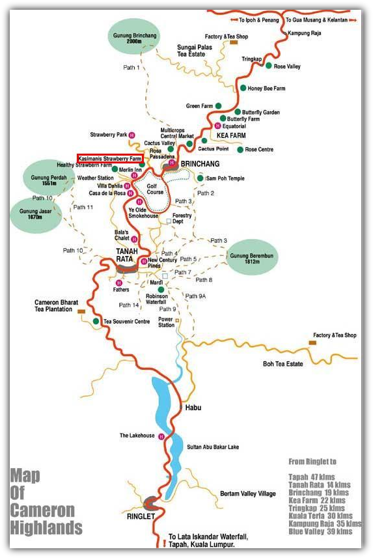**KASIMANI'S STRAWBERRY FARM**\Lot 1015, Jalan Strawberry Park, Tanah Rata,  
39100 Cameron Highlands, Pahang Darul Makmur, Malaysia. Tel: +605 4911160 l +6019 5218788 l +6019 4261408 Located near the Cameron Highlands Golf Course. If you are driving on the main road from Tanah Rata to Brinchang, turn left right after you pass the golf course club house. The Kasimanis Strawberry Farm offers self-picking. **Free Entry! OPENING HOURS : 8.30am - 6.00pm daily**

Besides the fruit strawberries, you will also be able to taste delicious, mouth-watering strawberry lassi, pickled strawberry, strawberry yoghurt, strawberry milkshake, strawberry ice cream and much more. You will be able to see many ranges of strawberries products. You also should not miss out trying the homemade strawberry jam, strawberry ice and strawberry syrup.

**KASIMANIS' STRAWBERRY FARM**   
**Lot 103, Jalan Kemunting,**   
**39000 Tanah Rata**   
**Tel: 605-4912260**

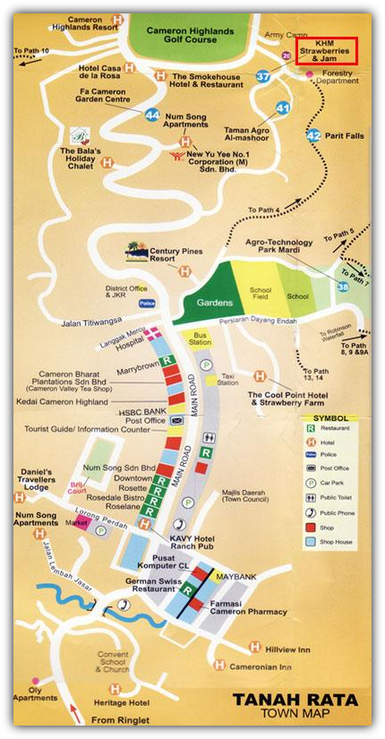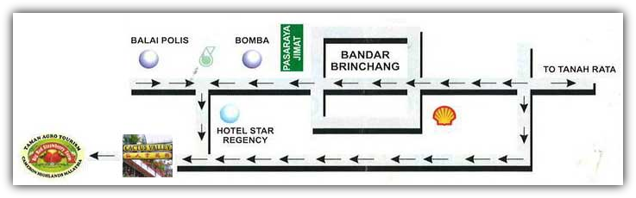**Big Red Strawberry Farm \**Brinchang, Cameron Highland, Pahang.  
  
Tel: +605-4913327\Red Strawberry Farm, also known as Taman Agro Tourism Cameron Highlands offers one-stop garden and farm centre to relax and unwind. It is located in Brinchang town, right beside Cactus Valley at the new town of Brinchang. If you are staying in Brinchang, ask the receptionist at your hotel and they can guide you on how to reach there. Alternatively, identify Star Regency Hotel/Apartment and it is only about 500 m from this place.  
  
Same location as Cactus Valley. From the main road, turn into road where Star Regency is located. Take a right at the junction and go in about 200 metres.  
  
Free Entry! OPENING HOURS : 8.30am -5.30pm daily -Pick Your Owen Strawberries! Available!

**KHM Strawberry Farm No. 9, Taman Sedia, 39000 Tanah Rata, Cameron Highlands  
Tel & Fax: 05-4911836\Free Entry!  
OPENING HOURS : 8.30am - 6.00pm daily  
-Pick Your Owen Strawberries! Available!  
-Home-made ice-cream**

[**Healthy Strawberry Farm**](http://www.cameron-highlands.com/directory/farms-and-markets/healthy-strawberry-farm/details/)

Jalan Rumah Persekutuan, Tanah Rata, 39000 Cameron Highlands, Pahang. 05-4911724

|  |
| --- |
|  |

*i am growing strawberries since 1963 on field and hydroponics,like to share my knoledge with strawberry growers."*   by joseph assa

**Contact Info:**  
F-12, Green Cow,  
Kea Farm,  
39000 Cameron Highlands  
Pahang  
Tel: 05-491 4649

\\**Raju's Hill Strawberry Farm  
42nd miles, Kea Farm, 39100 Cameron Highlands  
  
Tel: +6019 575 3867 l +605 491 4649 l +605 491 1649**

**\\KASIMANIS' STRAWBERRY FARM**   
**Lot 103, Jalan Kemunting,**   
**39000 Tanah Rata**   
**Tel: 605-4912260**

**\\KEA STRAWBERRY GARDEN**   
**MDCH 187, Kea Farm**   
**39100 Brinchang**   
**Tel: 605-4911940**

**\\EQ Strawberry Farm**  
Nº. 78, Jalan Kuari, Brinchang,  
Cameron Highland   
Pahang 39100 Malaysia  
Tel: 05-491 1759

\\ Red Strawberry Farm Tel：605-4913327 **Operating hours**: Open Daily from 8:30am to 5:30pm

\\**KHM Strawberry Farm  
No. 9, Taman Sedia, 39000 Tanah Rata, Cameron Highlands  
  
Tel & Fax: 05-4911836**

**\\**[**Healthy Strawberry Farm**](http://www.cameron-highlands.com/directory/farms-and-markets/healthy-strawberry-farm/details/) http://www.cameron-highlands.com/images/M_images/rating_star.pnghttp://www.cameron-highlands.com/images/M_images/rating_star.pnghttp://www.cameron-highlands.com/images/M_images/rating_star_blank.pnghttp://www.cameron-highlands.com/images/M_images/rating_star_blank.pnghttp://www.cameron-highlands.com/images/M_images/rating_star_blank.png

|  |
| --- |
| Jalan Rumah Persekutuan, Tanah Rata, 39000 Cameron Highlands, Pahang., [Map](http://maps.google.com/maps?q=Jalan+Rumah+Persekutuan%2C+Tanah+Rata%2C+39000+Cameron+Highlands%2C+Pahang.+++)  Telephone: 05-4911724 |